# **2D Fast Multipole Boundary Element Method Algorithm Implementation and Analysis on CAE**

|  |  |  |
| --- | --- | --- |
| Juan C Gutiérrez Urrego  Universidad EAFIT  Colombia  jcgutierru@eafit.edu.co | Simón Marín Universidad EAFIT Colombia smaring1@eafit.edu.co | Mauricio Toro  Universidad EAFIT  Colombia  mtorobe@eafit.edu.co |

# **ABSTRACT**

This paper provides an analysis of the Fast Multipole Boundary Element Method, and a comparison with the classical Boundary Element Method and the Finite Element Method in terms of algorithm complexity in time and memory, advantages, and disadvantages of them in Engineering applications.

The algorithm proposed to be programmed was the Fast Multipole Boundary Element Method, as it powers up the classical BEM, reducing its complexity and making possible to solve large scale problems without needing a supercomputer.

## **Keywords**

|  |
| --- |
| Boundary Element Method, Fast Multipole Method,  Algorithm Complexity, Computed aided engineering |

# **1. INTRODUCTION**

Nowadays, numerical methods for solving initial value problems in engineering such as structural, fracture and fluid mechanics, heat transfer and electromagnetism for example, are one of the main tools that an engineer must approximate to large scale solutions. As a result, studying time and memory complexity of these algorithms and methods is a constant concern for us. In this paper, I will analyze and discuss, a couple of algorithms that are used to solve this kind of problems and will compare their results.

# **Problem**

In this semester, I will be analyzing some engineering 2D plane stress problems by modeling and running them with different numerical methods/algorithms, to compare and conclude about the advantages and disadvantages that comes with them in terms of time and memory complexity, and precision.

**1.2 Solution**

The algorithm of interest, and the chosen one to be developed is the Fast Multipole Boundary Element Method, as it has the advantages of the initial discretization and the complexity improvement of the Fast Multipole Method.

**1.3 Article structure**

In what follows, in Section 2, will be presented the related work to the problem. Later, in Section 3, the data sets and methods used in this research. In Section 4, the algorithm design. After, in Section 5, the results. Finally, in Section 6, will be discussed the results and some future work directions will be proposed.

**2. RELATED WORK**

## In what follows, I will explain four related works on the domain of engineering numerical methods and Fast Multipole method implementation in one of them.

## **3.1 Finite Element Method**

This article widely explains the process that a problem goes through when you plan to apply FEM on an engineering problem. From it, can be concluded that this method is the most used nowadays for solving engineering problems, due to its versability and as it is capable of being used in non-linear problems. But on the other hand, it needs a lot of time and memory to create the mesh needed to solve the differential equations formulation. This mesh needs to cover the volume for 3D problems, and the entire area for 2D problems, this observation is made for a later comparison with the other methods.

This article also shows and explains that the first requirement of any analysis is the selection of an appropriate mathematical model to represent the physical problem; as well an example in a cantilever beam with a whole. [2]

## **3.2 The fast multipole boundary element method for potential problems: A tutorial**

This paper is an introduction to the Fast Multipole BEM for potential problems, first explaining how the Boundary Integral Equations are responsible of these applications and bringing some historical context to the reader. It points out the fact that the classic boundary element method owes its fame to the easy meshing process, as for solving problems only meshing the boundary is required, reducing 3D problems to 2D surface faces, and 2D problems to 1D borders of the object.

Also, the conventional boundary element equations are shown, and the way the classic BEM works is exposed and explained, to finally go through the fast multipole method formulation where the complexity reduction comes in, basically because the solver works with an **octree-quadtree** initial discretization, and iterative solvers do not need to store the entire matrix in memory. It finally shows a graphic where the difference in CPU time for FMMBEM and BEM can be clearly seen. [3]

**3.3 The Fast Multipole Method: Numerical Implementation**

This paper explained the fundamentals of fast multipole method, and how it is one of the most efficient methods used to perform matrix-vector products and accelerate the resolution of the linear system. In which a problem of N degrees of freedom may be solved in CNiter N log N floating operations, whew C is a constant depending on the implementation of the method. The main advantage of this method is that implies a lower total CPU time and a large range of applications, as I will discuss later with the Boundary Element Method. The paper in my opinion is dense but covers a lot of theorical explanation and equation examples of this method’s application. [4]

## **3.4 A new fast multipole boundary element method for solving large‐scale two‐dimensional elastostatic problems.**

## This paper shows in a more detailed way the implementation of the Fast Multipole Method and compares results of stress and displacement between BEM and FEM, in order to show the precision between the methods.

## The main idea of this article is to explain another way to implement Fast Multipole Method equations in BEM problems written in complex form. It shows some time complexity comparations and some numerical examples implementing this method. [5]

## **3. MATERIALS AND METHODS**

In this section, will be described the different stress-deformation problems that were used to compare the results of the implemented methods. And so, the software that was used to execute these methods.

## **3.1 Data Collection and Processing**

To compare the different alternatives, three problems were defined for testing them. To completely define a mechanical problem of interest for this application, the thing that must be defined are: The geometry of the problems, loads, and material properties.

The material used for all developed solutions was a 2014-T6 aluminum alloy, with an Elastic modulus (E) equal to 72400 N/mm2, a Shear modulus (G) equal to 28000 N/mm2 and a Poisson’s ratio (Nu) equal to 0.33.

The first problem formulation will be a cantilever beam, with a 100 N/mm2 distributed force at the free end of it, with a length of 200mm, a height of 20mm and a base of 1mm as for the 2D simplification it needed to be unitary.

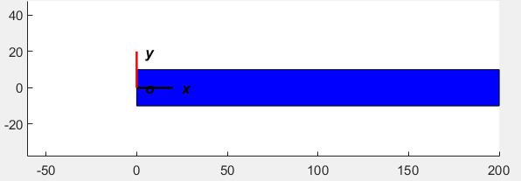

**Figure_. Cantilever Beam**

The second one will be a semicircular tunnel, with a uniformly radial distributed pression of 100 N/mm2, a radius of 15m and a thickness of 3m, and the displacement in the base will be zero.

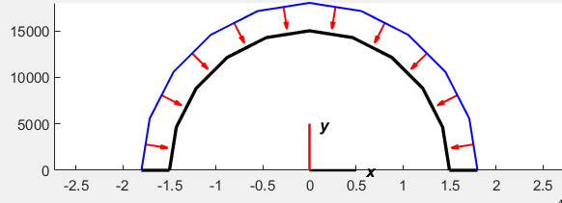

**Figure_. Tunnel**

For the last problem, I will define a cylindrical tank, and the analyzed part will be a cross-section showing the circular shell, which will have a uniformly radial distributed pression of 250 N/mm2, a radius of 5 meters, and a thickness of 5 centimeters.

\ 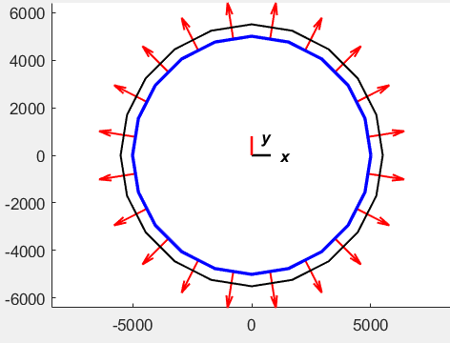

**Figure_. Tank cross-section**

## **3.2 Numerical method alternatives**

## In what follows, I will present different algorithm/ methods used for solving the problems.

**3.2.1 Finite Element Method**

For this method I used the very known software SolidWorks, which brings a high reliability as it is a commercial software used and recommended around the world. For solving the 2D problems, I will be using the 2D simplification option that SolidWorks provides, and that I am familiar with because of my past work using this method.

**3.2.2 Indirect Boundary Element Method**

For this method I will be using a software developed by the Professor Juan Diego Jaramillo on FORTRAN, which was brought to us his students for a first approaching to the BEM method. As this algorithm needs a first problem “handmade” parametrization, I will be using MATLAB and Excel as well to define all these parameters, such as, material properties, nodes, type of nodes, loads, etc.

**3.2.3 Boundary Element Method**

For this method I will be developing my own code on Python and will be analyzing the time and memory complexity that it achieves.

**3.2.4 Fast Multipole Boundary Element Method**

I will be developing this software for my next work, as I might not have enough time to complete it, but I will compare theoretical results and will explain and work on the process to achieve it.

## **3.3 Analytical Solution**

## For two of these three problems, the analytical solution is available on academic records, so it will be possible to compare the numerical methods and algorithms against the goal solution, but for most cases in engineering, there is not such a thing as the analytical solution for a complex problem, basically that is why numerical solutions are used. So, I will be comparing for the other case the approximations between the methods themselves.

**Table 2:** Time Complexity of the image-compression and image-decompression algorithms.

**6.1 Future work**

I am planning to implement the Fast Multipole Boundary Element Method for other engineering applications such as heat transfer or fluid dynamic and explore the potential of this algorithm for modern problems.

# **REFERENCES**

2. Klaus‐Jürgen Bathe. 2008. Finite Element Method. (June 2008). Retrieved May 17, 2021 from <https://onlinelibrary.wiley.com/doi/abs/10.1002/9780470050118.ecse159>

3. Y.J. Liu and N. Nishimura. 2006. The fast multipole boundary element method for potential problems: A tutorial. (March 2006). Retrieved May 17, 2021 from https://www.sciencedirect.com/science/article/abs/pii/S0955799706000105

4. Eric Darve. 2002. The Fast Multipole Method: Numerical Implementation. (May 2002). Retrieved May 22, 2021 from https://www.sciencedirect.com/science/article/pii/S0021999100964519

5. Yijun Liu. 2005. A new fast multipole boundary element method for solving large‐scale two‐dimensional elastostatic problems. (September 2005). Retrieved May 17, 2021 from https://onlinelibrary.wiley.com/doi/abs/10.1002/nme.1474